Garden Experiences
at Crazy 8 Barn & Garden
Our garden experiences encourage you to enjoy our story of creating this garden of perennials and rare or unique native trees. The experiences are small, intimate groups, where you will discover “WOW” moments. You will receive a take away item and learn interesting tidbits of our area’s story. “Pick, Press, preserve” is the first VisitCK Signature Experience.
- Summer Experiences
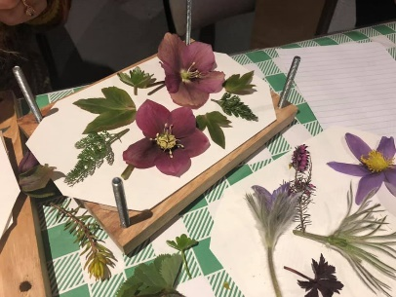
- Pick, Press, Preserve – A 2½ hour experience where you will personalize your own flower press made from local, reclaimed wood. During a guided tour, you will choose unique blooms and leaves to “press”. We’ll talk about the uses of pressed plants and how you can use your press on future adventures. Offered some Wednesday evenings and Saturday mornings throughout the growing season.
$100 plus tax … $113.00 Minimum of 4 people, Maximum of 8

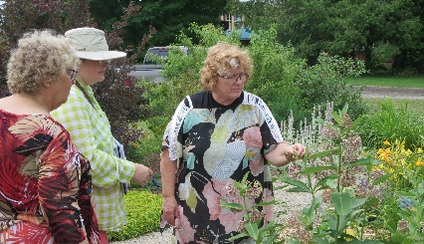
- Tuesday Garden Tour & Lunch – An exclusive one hour long inspirational tour of our garden & delicious brown bag lunch with Susanne. She has many stories that may interest you from tree seed collecting, landscape design, rare Carolinian species and will discuss all of your gardening opportunities.
$29. plus tax = $32.77 includes lunch.

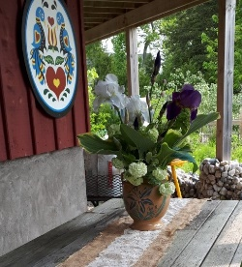
- Picnic in the Garden – Reserve a Picnic in the garden for groups of 2 to 8. We will have your picnic lunch prepared for you: Chilled chicken breast, pasta salad, lettuce salad, bean salad, corn muffin, tart and chilled sparkling apple cider. You’ll take your basket into the garden and enjoy.
$19.95 per person plus tax. = $22.55

You can book # 1 & 2 online at www.crazy8barn.com or www.facebook.com/crazy8barn/events and etransfer or book in person
Picnics can be booked by calling 519-674-2888 or email info@crazy8barn.com
